**WEEK-1: TASK-3**

1. **Understand Asymptotic Notation:**
   * Explain Big O notation and how it helps in analyzing algorithms.
   * Describe the best, average, and worst-case scenarios for search operations.
2. Big O notation is a mathematical representation used to describe the upper bound of an algorithm's running time as the input size grows.

| **Case** | **Linear Search** | **Binary Search** |
| --- | --- | --- |
| **Best** | O(1) | O(1) |
| **Average** | O(n) | O(log n) |
| **Worst** | O(n) | O(log n) |

1. **Setup and Implementation:**

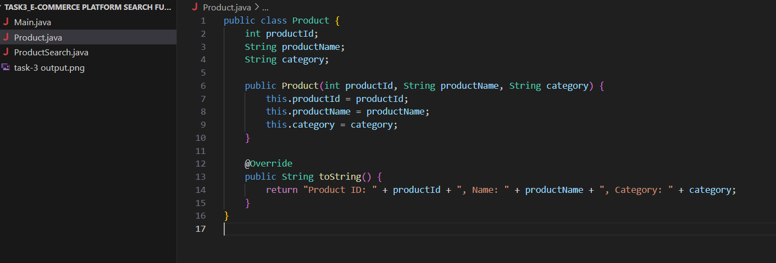

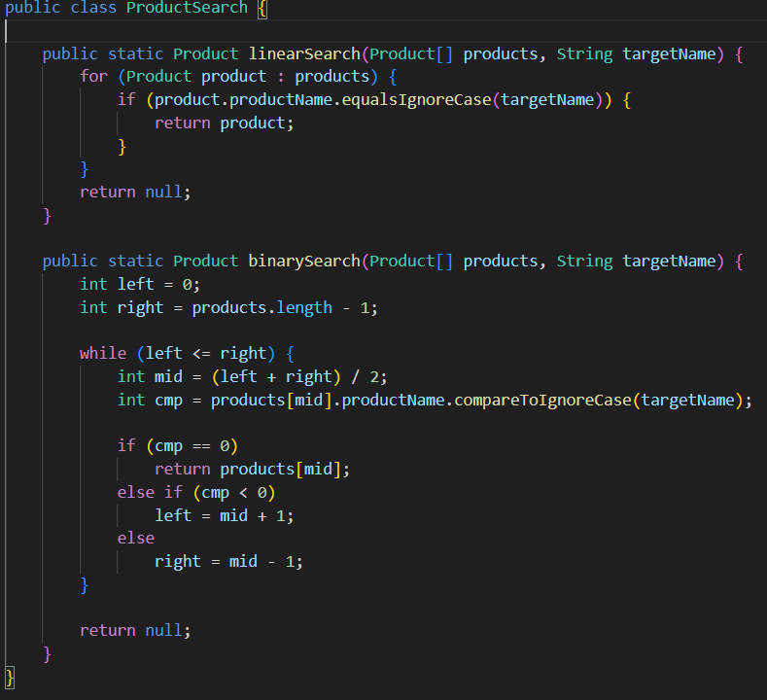

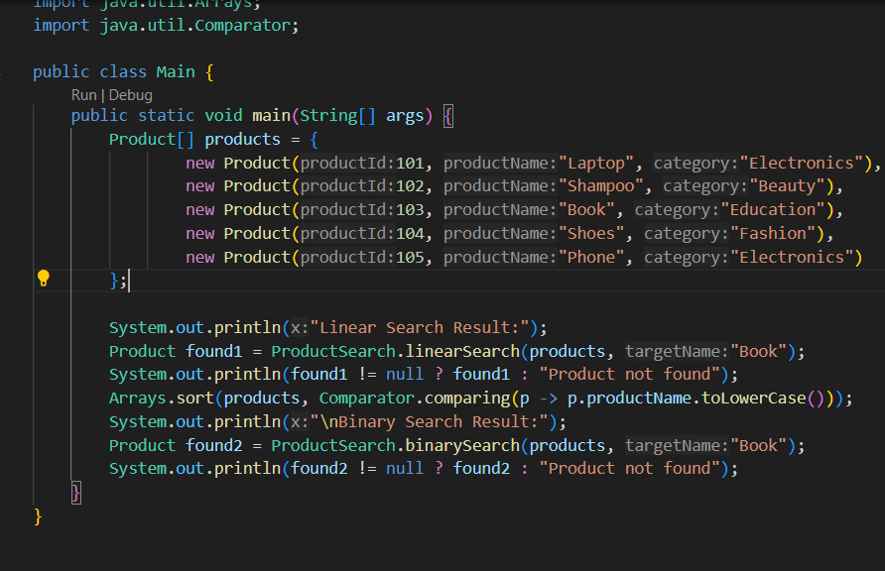

1. **Analysis:**

**Time Complexity Comparison:**

| **Algorithm** | **Time Complexity** | **Suitable For** |
| --- | --- | --- |
| **Linear Search** | O(n) | Small/unsorted datasets |
| **Binary Search** | O(log n) | Large/sorted datasets |
|  |  |  |

* **Linear Search** is simple but inefficient for large datasets.
* **Binary Search** is highly efficient **but requires sorted data**.

**Output:**

